
NP SERIES 12V
Valve Regulated Lead Acid (VRLA) Batteries


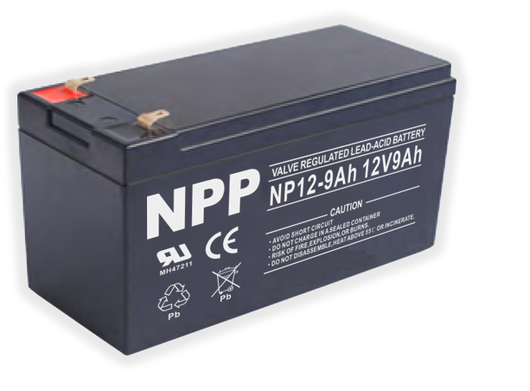

- Non – Spillable
- Sealed and Maintenance-Free Battery
- High Quality and High Reliability
- Absorbent Glass Matt (AGM) Technology
- 13.5V to 13.8V Standby Voltage
- Computer - Aided Design and Manufacturing
- CE Approved


Model | Nominal Voltage | Rated Capacity | Approx. Dimension  （mm） |  |  | Terminal  type
Model | Nominal Voltage | Rated Capacity | Length | Width | Height | Terminal  type
Model | Nominal Voltage | Rated Capacity | ±3 | ±3 | ±3 | Terminal  type
NP12-7AH | 12VDC | 7AH | 151 | 65 | 95 | T1/T2
NP12-9AH | 12VDC | 9AH | 151 | 65 | 95 | T1/T2
NP12-12AH | 12VDC | 12AH | 151 | 98 | 95 | T1/T2
NP12-18AH | 12VDC | 18AH | 181 | 77 | 167 | T3/T12
NP12-26AH | 12VDC | 26AH | 166 | 175 | 125 | T4/T12
NP12-40AH | 12VDC | 40AH | 197 | 165 | 170 | T14
NP12-55AH | 12VDC | 50AH | 230 | 138 | 211 | T14
NP12-65AH | 12VDC | 65AH | 350 | 166 | 179 | T14
NP12-80AH | 12VDC | 80AH | 260 | 169 | 211 | T14
NP12-90AH | 12VDC | 90AH | 306 | 169 | 211 | T14
NP12-100AH | 12VDC | 100AH | 330 | 171 | 214 | T16
NP12-120AH | 12VDC | 120AH | 409 | 176 | 225 | T16
NP12-150AH | 12VDC | 150AH | 485 | 172 | 240 | T16
NP12-200AH | 12VDC | 200AH | 522 | 238 | 218 | T18
NP12-250AH | 12VDC | 250AH | 521 | 269 | 220 | T18

Exclusive Distributor
AUTOMATION SPECIALISTS AND POWER EXPONENTS, INC.
ASPEX Bldg., 159 Boni Avenue, Brgy. Plainview, Mandaluyong City
Trunk line: (02) 8997-0000 Fax: (02) 8532-7228
www.aspexinc.com.ph

